Heuristic Analysis

By Akash Chauhan

This script evaluates the performance of the custom_score evaluation

function against a baseline agent using alpha-beta search and iterative

deepening (ID) called `AB_Improved`. The three `AB_Custom` agents use

ID and alpha-beta search with the custom_score functions defined in

game_agent.py.

*************************

Playing Matches

*************************

|  |  |  |  |  |  |  |  |  |  |
| --- | --- | --- | --- | --- | --- | --- | --- | --- | --- |
| # | Opponent | AB_Improved | | AB_Custom | | AB_Custom_2 | | AB_Custom_3 | |
|  |  | Won | Lost | Won | Lost | Won | Lost | Won | Lost |
| 1 | Random | 7 | 3 | 8 | 2 | 8 | 2 | 8 | 2 |
| 2 | MM_Open | 8 | 2 | 5 | 5 | 7 | 3 | 6 | 4 |
| 3 | MM_Center | 6 | 4 | 8 | 2 | 6 | 4 | 10 | 0 |
| 4 | MM_Improved | 6 | 4 | 6 | 4 | 6 | 4 | 7 | 3 |
| 5 | AB_Open | 4 | 6 | 7 | 3 | 4 | 6 | 5 | 5 |
| 6 | AB_Center | 5 | 5 | 5 | 5 | 5 | 5 | 5 | 5 |
| 8 | AB_Improved | 5 | 5 | 4 | 6 | 5 | 5 | 4 | 6 |
|  | Win Rate: | 58.6% | | 61.4% | | 58.6% | | 64.3% | |

Your ID search forfeited 249.0 games while there were still legal moves available to play.

### 1. custom_score:

This heuristic is a combination of two heuristic function

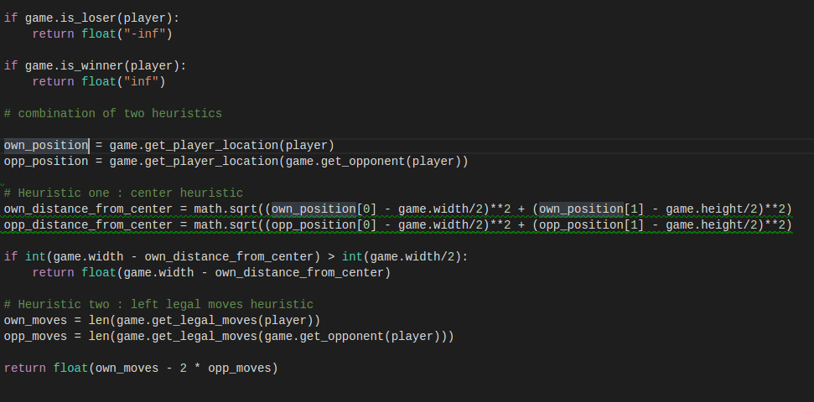 a. center heuristic the player which is closer to the center can do better comparing to the case when he is far from the center

b. left legal moves: that states the condition of player comparing to the opponents 50% more moves. Heuristic change point: when player is closer to the center than the opponent, if the player is far then the b heuristic comes into play.

### 2. custom_score_2:

Center Heuristic: it states that the player near to the center has better chances to win the game.

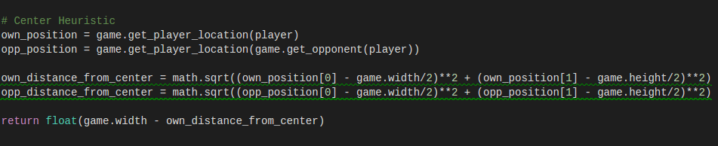

### custom_score_3:

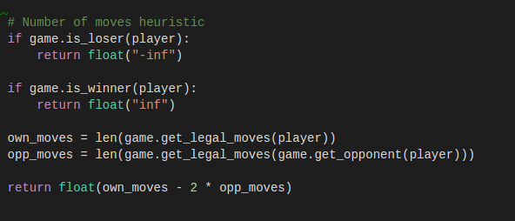Legal moves left heuristic: this one is intuitive, one with the more moves available has more chances to win.